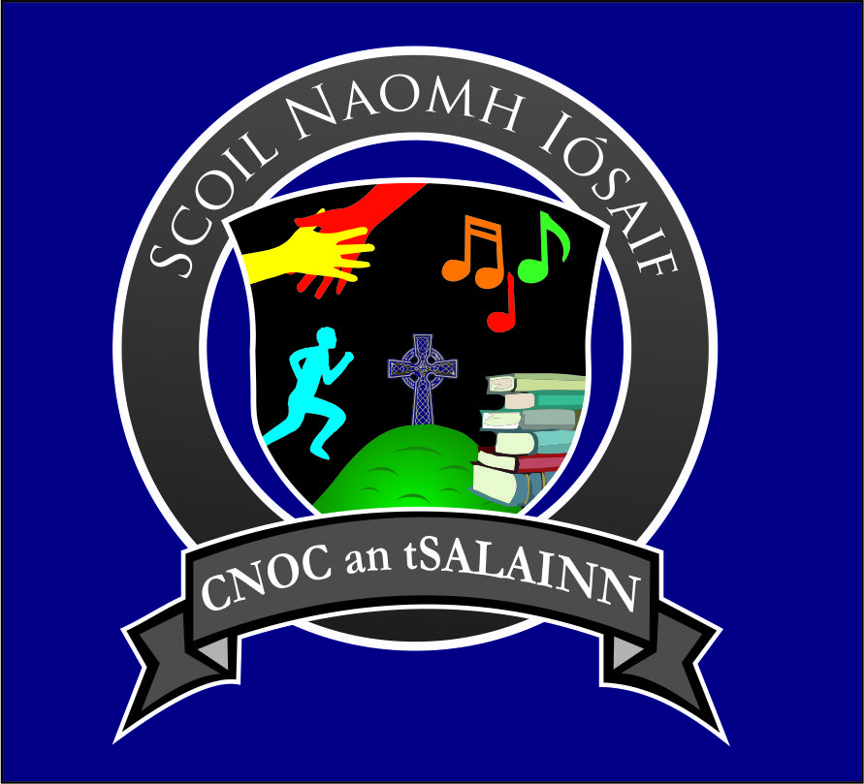
Knockatallon,
Co. Monaghan
Roll Number 20067U

TRANSFER APPLICATION FORM 2024/2025 – PRIVATE AND CONFIDENTIAL

Section 1 - Child’s Details:

Name (as on Birth Certificate): _________________________ Date of Birth: _______________ Male Female
Address: ______________________________________________________________Eircode:_______________________
Number of children in the family: ______ Child’s place in the family: _______ Siblings in this school: ___________________
Religious Denomination (if any): _________________________ Country of origin: _________________________________
Place of Baptism (if applicable): ___________________________ Please attach copy of Baptismal Certificate if baptised outside the parish.
How long has the child been living in Ireland? ________ What language(s) are spoken at home? ______________________

PPSN of Child: ________________________________ Does the family have a medical card? Yes No
**Please attach your child’s Birth Certificate

Class group applying for (please tick):

Senior Infants 1st Class 2nd Class 3rd Class

4th Class 5th Class 6th Class

Section 2 – Parent(s)/Carer(s) Details:

Parent/Carer 1 (full name, address and Eircode):___________________________________________________________ ____________________________________________________________ Relationship to child: ____________________ Email Address (print): __________________________________________ Occupation: ___________________________ Religious Denomination: _____________ Country of Origin: _______________ Language(s) spoken: __________________
Home phone: ______________________ Mobile phone: _________________ Work phone: _________________________

Parent/Carer 2 (full name, address and Eircode):____________________________________________________________ ____________________________________________________________ Relationship to child: ____________________ Email Address (print): __________________________________________ Occupation: ___________________________ Religious Denomination: _____________ Country of Origin: _______________ Language(s) spoken: __________________
Home phone: ______________________ Mobile phone: _________________ Work phone: _________________________

Section 3 – Emergency Contact Details (other than parent(s)/carer(s), e.g. grandparent, family friend, neighbour)
1. Name and Address: _______________________________________________________________________________
Relationship with Child: _______________________________________ Phone No: _______________________________

2. Name and Address: _______________________________________________________________________________
Relationship with Child: _______________________________________ Phone No: _______________________________

Section 4 – Childminding/Crèche Details (if applicable)
Name and Address: ___________________________________________________________________________________
Phone Number: _________________________ Days of week child attends: ______________________________________

Section 5 – Playschool/Pre-school/Other Primary School Details
- Playschool/Pre-School

Has your child attended a preschool group/playschool? Yes No (If yes, please provide details below)

Type/Name: _______________________________________ Year(s) Attended: ________________

- Previous Primary School

Has your child attended another primary school? Yes No (If yes, please provide details below)
Name and Address of School: ___________________________________________________________________________
___________________________________________________________________________________________________
Principal’s Name: ________________________________________ Year(s) Attended: _____________________________
(Please provide a written report from your child’s previous primary school)

I give permission to Aisling Kelly (Principal) and relevant members of staff of St. Joseph’s National School to discuss the needs of my son/ daughter, with the manager/ Principal of the pre-school/ schools listed above. Yes No

Section 6 – Referrals/Special Needs
Has your child ever been referred to any of the following?

Speech Therapy: Yes No (If yes, please provide details below)
______________________________________________________________________________________________________________________________________________________________________________________________________

Occupational Therapy: Yes No (If yes, please provide details below)
______________________________________________________________________________________________________________________________________________________________________________________________________

A psychiatric/psychological assessment: Yes No (If yes, please provide details below)
______________________________________________________________________________________________________________________________________________________________________________________________________

Does your child have any Special Educational Needs? Yes No (If yes, please provide details below)
______________________________________________________________________________________________________________________________________________________________________________________________________
**If you answered yes to any of the above, please make an appointment to speak to the Principal**
**If your child has had an assessment, please enclose a copy of this for the school**

Section 7 – Medical Consent/H.S.E.
I give my consent to the school to give my contact details to the HSE for the purpose of school medicals such as sight tests, hearing tests, dental check-ups, injections etc.: Yes No

I give my consent for my child to be brought to and treated at hospital in the case of an emergency: Yes No

Doctor’s Name: _________________________________________ Doctor’s Phone No: ____________________________

**Please complete Medical Conditions and Allergies form also – see attached

Section 8 – Additional Consent
School events may be featured on television, radio, newspapers, school-related websites, Facebook, Twitter page etc. Do you give permission for your child’s photograph to be featured with their class? Yes No

Please visit our school website www.knockatallonns.com Do you give permission for your child’s photos/ videos to be used on the school website? Yes No

During the school year, the children may leave the school grounds for picnics, sponsored walks, sports activities etc. with their teacher(s) and other school staff. Do you give permission for your child to participate in these activities outside the school grounds? Yes No

If your child transfers to another primary school, and when they transfer to post-primary school, do you give permission for this school to share relevant documentation relating to your child, including school reports and details of any assessment carried out? Yes No

I confirm that I understand and support the Catholic Ethos of this school: Yes No

PLEASE ENSURE THAT NO BLANKS SPACES HAVE BEEN LEFT ON THIS FORM

Signature of Parent(s)/Guardian(s): _________________________________________ Date: _____________________
_________________________________________ Date: _____________________

Official School Use Only

Copy of Birth Certificate taken and on file: Yes No Registration No: _________________
Copy of Baptismal Certificate taken and on file (if baptised outside the parish): Yes No N/A

Previous school report supplied: Yes No N/A Class: ____________________________________________

Copy of assessment received: Yes No N/A Date of Entry: ________________________________________

