How to access Google Classroom
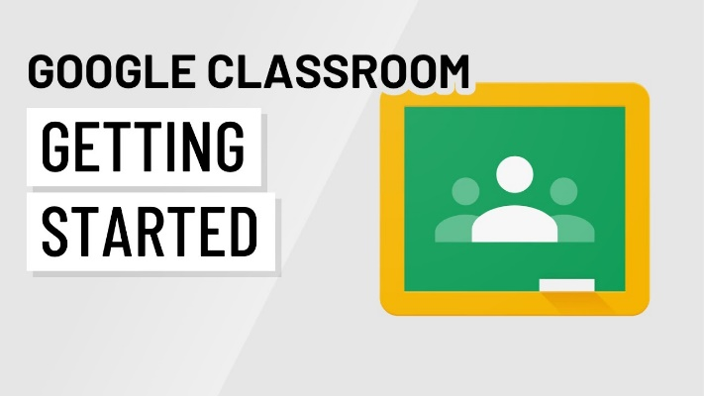

Tablet/ iPad
- Download the Google Classroom app.
- Sign in with your school username/ email address, for example abc@knockatallonns.com Please note that the email address will always end in @knockatallonns.com
- Use the password that was given to you by a member of our admin team at school. You may be prompted to change this password when you first log in to something you remember.
- If there is a welcome message, review it and click Accept.

Web Browser on Computer or Laptop
- Go to classroom.google.com
- Click Go to Classroom
- Sign in with your school username/ email address, for example ann@knockatallonns.com Please note that the email address will always end in @knockatallonns.com
- Use the password that was given to you by a member of our admin team at school. You may be prompted to change this password when you first log in to something you remember.
- If there is a welcome message, review it and click Accept.

Please note:
- Don’t forget to check the class stream often for messages and class updates.
- It’s important that you write down your log in details and keep them safe at home.
- If you forget your username and or password it’s important that you let a member of staff know. We can remind you of your email address and reset passwords!

